**Flexible Electronic Skin**

**A SEMINAR REPORT**

***In partial fulfillment for the award of the degree***

***of***

**BACHELOR OF TECHNOLOGY**

**IN**

**ELECTRONICS AND COMMUNICATION ENGINEERING**

***Under the Guidance of***

**Prof. SUBHAM PRAMANIK**

***Submitted By***

**ANINDYA SARKAR**

**(6th SEM, 16900317139)**

**AMIT PAUL**

**(6th SEM, 16900317142)**

AOT Logo

**ACADEMY OF TECHNOLOGY**

**Grand Trunk Road, Aedconagar, near Adisaptagram Railway Station**

**CERTIFICATE**

This is to certify that this proposal of seminar report entitled **“FLEXIBLE ELECTRONIC SKIN”** is a record of bona fide work, carried out by **1. ANINDYA SARKAR, 2. amit paul** under my guidance at **Academy of technology**. In my opinion, the report in its present form is in partial fulfilment of the requirements for the award of the degree of **BACHELOR OF TECHNOLOGY IN ELECTRONICS AND COMMUNICATION ENGINEERING** and as per regulations of the **UNIVERSITY*.*** To the best of my knowledge, the results embodied in this report, are original in nature and worthy of incorporation in the present version of the report.

**Guide / Supervisor**

**__________________________________________________________**

**Prof. Subham Pramanik**

Assistant Professor (Electronics and Communication Engineering Department)

at **ACADEMY OF TECHNOLOGY**

Grand Trunk Road, Aedconagar, near Adisaptagram Railway Station

**ACKNOWLEDGEMENT**

Success of any project depends largely on the encouragement and guidelines of many others. We take this sincere opportunity to express our gratitude to the people who have been instrumental in the successful completion of this project work.

Our heartfelt thanks to Dr.Abhijit Banerjee, HOD of Electronics & Communication Engineering of ACADEMY OF TECHNOLOGY, for providing us the opportunity to gain the knowedge of this seminar topic.

We would like to show our greatest appreciation to Prof. Subham Pramanik, Seminar Guide of this seminar. We always feel motivated and encouraged every time by his valuable advice and constant inspiration; without his encouragement and guidance this project would not have materialized.

Words are inadequate in offering our thanks to the other professors, assistants and other members at Academy of Technology for their encouragement and cooperation in carrying out this project work. The guidance and support received from all the members and who are contributing to this project, was vital for the success of this seminar.

Table of Contents

* **Abstract** 3
* **Keywords** 3
* **Introduction** 3
* **Block Diagram** 4
* **History and Evolution** 4
* **Architecture:** 9
* **Features** 10
* **Working:** 11
* **Desirable Properties For E-Skin** 13

• Biocompatibility and Biodegradability 13

• Self -healing 13

• Temperature sensitivity 13

• Self – Powering 13

Advantages 14

Disadvantages 14

* **Flowchart** 15
* **Applications** 16

• Biomedical Devices 16

• Robotics 17

• Optoelectronics 18

* Flexible Electronic Skin to sense Magnetic Fields 19
* **Future Scope** 20

• Self-healing electronic skin 20

• Lighting electronic skin 21

• Sweating electronic skin 22

• Other Scopes 22

* **Conclusions** 23
* **References** 24

**Abstract:**

Human skin is an important organ. It consists of an integrated, stretchable network of sensors that relay information about tactile and thermal stimuli to the brain, allowing us to move the organs within our environment safely and effectively. inspired by human skin an ELECTRONIC SKIN is created by artificial means used for autonomous intelligent robots and biometric prosthetics, among other applications. The development of electronic networks comprised of flexible, stretchable, and robust devices that are compatible with large-area implementation and integrated with multiple functionalities is a testament to the progress in developing an electronic skin (e-skin) to human skin. E-skins are already capable of providing augmented performance over their organic counterpart, both in superior spatial resolution and thermal sensitivity. They could be further improved through the incorporation of additional functionalities (e.g., chemical and biological sensing) and desired properties (e.g., biodegradability and self-powering).Continued rapid progress in this area is promising for the development of a fully integrated e-skin in the near future.

**Keywords:**

Artificial Skin, Biometric Prostheses ,Electronic Skin, MEMS Technology, Optoelectronics, Robotics, Self-Healing, Sensitive Skin, Super capacitors.

**Introduction:**

Human skin is highly intuitive, making it easy to neglect the complexity of the largest sensory organ in our body, SKIN. Our skin is the physical barrier through which we interact with our surroundings. It allows us to perceive various shapes and textures, changes in temperature, and varying degrees of contact pressure. To achieve such high sophistication in its sensing capabilities, several different types of highly specialized sense receptors are embedded within our skin. These receptors first transducer information generated by physical contact into electrical signals and subsequently send it to the central nervous systems for more complex processing. The collected signals are eventually interpreted by the somatosensory cortex, permitting us to successfully navigate our physical world with ease. The effort to create an artificial skin with human-like sensory capabilities is motivated by the possibility of such large, multi-sensory surfaces being highly applicable for autonomous artificial intelligence (e.g., robots), medical diagnostics, and replacement prosthetic devices capable of providing the same, if not better, level of sensory perception than the organic equivalent. Endowing robots with sensing capabilities could extend their range of applications to include highly interactive tasks, such as caring for the elderly, and sensor skins applied on or in the body could provide an unprecedented level of diagnostic and monitoring capabilities. An artificial skin with such sensory capabilities is called as sensitive skin, smart skin, or electronic skin (e-skin).

**Block Diagram:**

Input 8X8 Structured

Tactile Sensor Array

Digital Signal Processing

Interface Electronics

Information Sensors Information

Figure 1: Basic block diagram of electronic skin processing

**History and Evolution:**

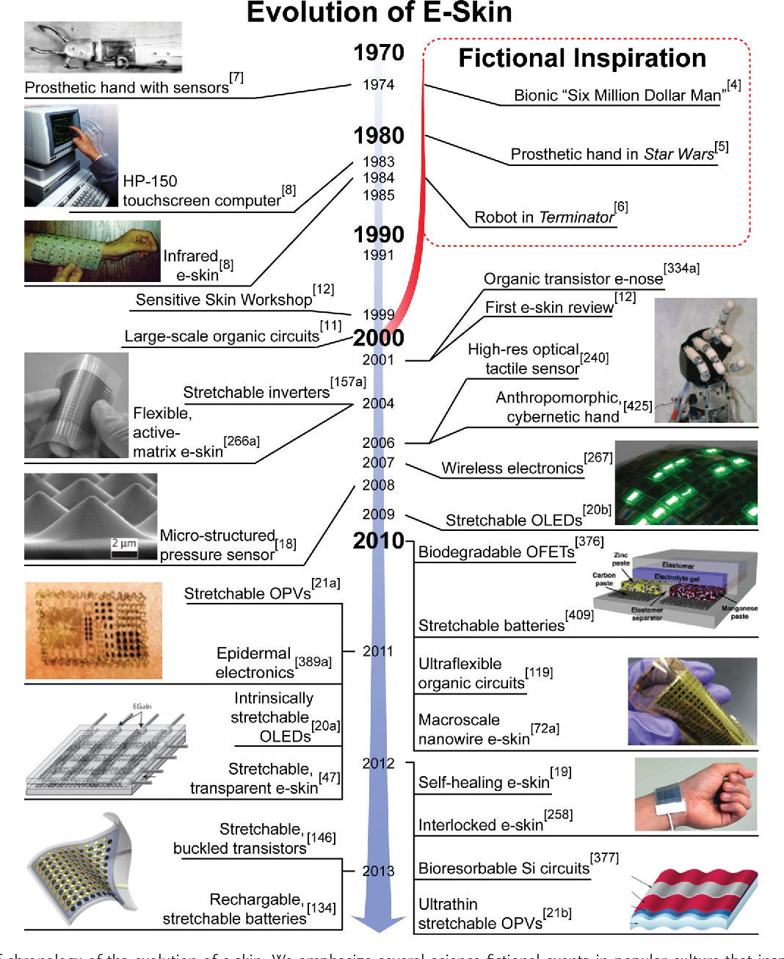

Figure 2: Evolution of Flexible Electronic Skin

The prospect of creating artificial skin was in many ways inspired by science fiction, which propelled the possibility of e-skin into the imagination of both the general public as well as the scientific community. One of the first science fiction books to explore the use of mechanical replacement organs was Caidin’s Cyborg in 1971, on which the famed Six Million Dollar Man television series about a man with a bionic replacement arm and eye was later based (1974). Shortly after, at the beginning of the 1980s, George Lucas created a vision of a future with e-skin in the famous Star Wars series. In particular, he depicted a scene showing a medical robot installing an electronic hand with full sensory perception on the main character, Luke Skywalker. Shortly after, in 1984, the Terminator movie series depicted humanoid robots and even a self-healing robot. These fictitious renditions of e-skin took place against a real-life backdrop of vibrant microelectronics research that began bridging science fiction with scientific reality.

Early technological advancements in the development of e-skin were concomitant with their science fiction inspirations. In 1974, Clippinger et al. demonstrated a prosthetic hand capable of discrete sensor feedback. Nearly a decade later, Hewlett-Packard (HP) marketed a personal computer (HP-150) that was equipped with a touchscreen, allowing users to activate functions by simply touching the display. It was the first mass-marketed electronic device capitalizing on the intuitive nature of human touch. In 1985, General Electric (GE) built the first sensitive skin for a robotic arm using discrete infrared sensors placed on a flexible sheet at a resolution of ≈5 cm. The fabricated sensitive skin was proximally aware of its surroundings, allowing the robot’s arm to avert potential obstacles and effectively maneuver within its physical environment. Despite the robotic arm’s lack of fingers and low resolution, it was capable of demonstrating that electronics integrated into a membrane could allow for natural human–machine interaction. For example, the robotic arm was able to ‘dance’ with a ballerina without any pre-programmed motions. In addition to the ability of an artificial skin to interact with its surroundings, it is equally critical that the artificial skin mimics the mechanical properties of human skin to accommodate its various motions. Hence, to build life-like prosthetics or humanoid robots, soft, flexible, and stretchable electronics needed to be developed.

In the 1990s, scientists began using flexible electronic materials to create large-area, low-cost and printable sensor sheets. Jiang et al. proposed one of the first flexible sensor sheets for tactile shear force sensing by creating silicon (Si) micro-electro-mechanical (MEM) islands by etching thin Si wafers and integrating them on flexible polyimide foils. Much work has since been done to enhance the reliability of large sensor sheets to mechanical bending. Around the same time, flexible arrays fabricated from organic semiconductors began to emerge that rivaled the performance of amorphous Si.

Just before the turn of the millennium, the first “Sensitive Skin Workshop” was held in Washington DC under the aegis of the National Science Foundation and the Defense Advanced Research Projects Agency, bringing together approximately sixty researchers from different sectors of academia, industry, and government. It was discovered that there was significant industrial interest in e-skins for various applications, ranging from robotics to health care. A summary of concepts outlined in the workshop was compiled by Lumelsky et al. In the early 2000s, the pace of e-skin development significantly increased as a result of this workshop, and researchers began to explore different types of sensors that could be more easily integrated with microprocessors.

**Flexible Electronics:**

A generic large-area electronic structure is composed of a substrate, a backplane and a frontplane system and an encapsulation. To make the structure flexible, all components must comply with bending to some degree without losing their function and without delamination.

In other words, flexible electronics also known as “flex circuits”, is a technology for assembling electronic circuits by mounting electronic devices on flexible plastic substrates. Commonly, the substrates are made of polymide, PEEK or transparent conductive polyester film.

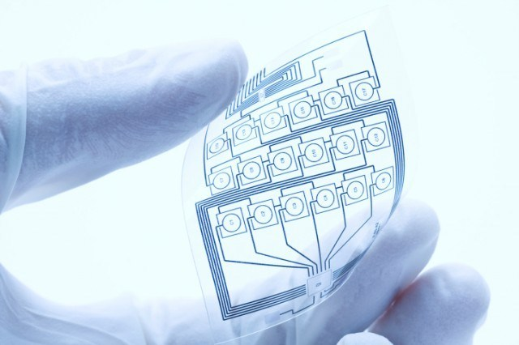

Figure 3: A flexible electronic alias flex circuits

Flexible electronics have a long history. The first flexible device was made in the 1960s by thinning crystalline silicon solar cells for use in extraterrestrial satellites. Today, smart credit cards carry bendable microchips which are made using stretchable Silicon.

Materials are the heart of this technology. Flexibility can be attributed to a myriad of qualities ranging from how bendable a device is to whether it is manufactured using roll-to-roll process.

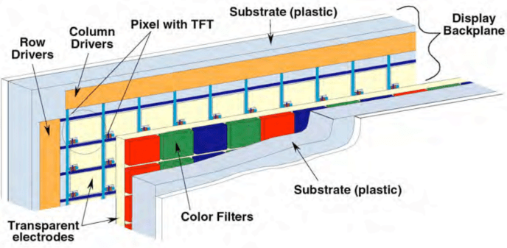In this module we are mainly focusing on the role materials science played to aid the growth of a segment in flexible electronics which is largely associated with active thin-film transistor(TFT) circuits. Thin Film Transistors(TFT’s) switch-on or switch-off each pixel on the display. High Performance TFT’s are extremely important.

Figure 4: Display electronics on flexible plastic substrates

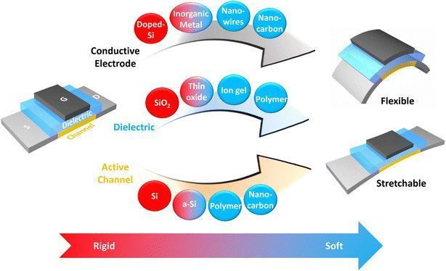Silicon Technology has been the main driving force behind miniaturizing devices to reduce costs while improving its performance. The material rigidity of silicon is an impasse of its ubiquitous use in soft electronic(flexible and stretchable technologies) applications. This resulted in an extensive search of prospective materials by the research community that has the potential to overcome the rigidity of conventional silicon technology. From this flexible electronic components and integration with artificial skin has been a great step in technological history.

Figure 5: Flexible electronic materials classified from rigid to soft

Nano-carbon materials as carbon nanotubes(CNTs) and grapheme are promising due to outstanding elastic properties as well as an excellent combination of electronic, optoelectronic, thermal properties for modification of flexible electronic skin.

With a strong proof of concept for flexible batteries and soft electronics the industry will witness a fusion of wearable technology with flexible electronics which I feel would be a critical advancement in the industry. Organic sensors will progress and features like gesture recognition, contactless control, and biometric sensor arrays would be made commercially ubiquitous. “Stretchable silicon” will be a heavily researched field as nano-carbon materials will be unable to match the speed of silicon. Already commercialized LED, LCD technology may slow the growth of flexible electronics but the new era of electronics is real and flexible electronics are here to stay.

# **Architecture:**

Electronic skins for robots and medical prostheses—multifunctional structures, in which sensors and actuators are closely integrated with microelectronic circuits—bring a new dimension to electronics flexibility. Shaped electronics and skin-like electronics may experience large deformation strains. A disk detector array may see its surface area double to be shaped as a hemispherical detector array. When wrapped over elbow like joints, the skin may be stretched and relaxed many times by 15%. Semiconductor integrated circuits and MEMS technology use rigid and stiff substrates that are not adapted to flexible structures, and thin active device materials that fracture at a critical strain of 1% .Free-standing thin metal films also break under tensile strain of the order of 1%.

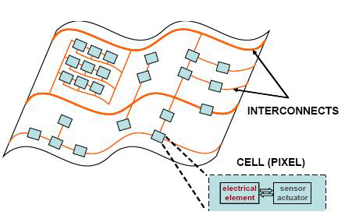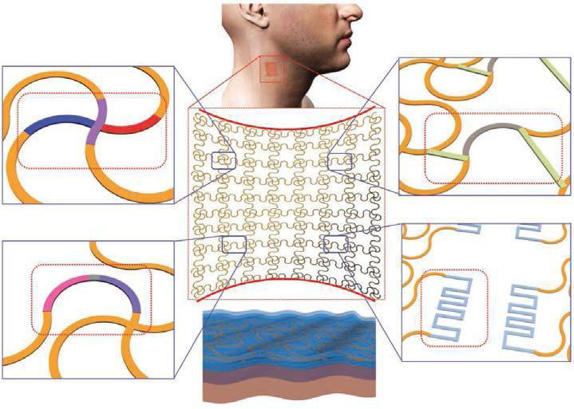

Figure 6: island carrying electronic surface Figure 7: Detailed view of inner circuit of electronic skin

To achieve flexible and stretchable skin, sub circuit cells, made of a transducer and an electronic circuit, will be placed on mechanically separated islands, which are fabricated on a deformable substrate that takes up most of the total strain. The figure shown above is a sketch of such an island carrying electronic surface. The islands are made sufficiently rigid to protect them from breaking when the circuit is deformed one time or by repeated stretching. The sub circuits are electrically connected with stretchable metal conductors.

We have three options for making deformable interconnects: making thin metal films that can withstand large plastic deformation, deforming a sacrificial mask which serves in liftoff metallization, and making stretchable metallization.

**Features:**

The electronic skin concept was initially developed for applications in robotics.Robots could be provided with pressure sensing (―touch‖) that would allow them to grip objects securely without damaging them (the ―picking up an egg‖ problem). These electronic skins, which mainly consist of pressure- sensing materials and associated electronic devices for pressure reading, might also provide touch sense to prosthetic devices such as artificial legs or arms. One challenge for making these devices is that the transistors (and the semiconductors in them) that amplify weak signals must be flexible in order to act like skin. The ability of transistors to amplify signals, their gain depends on the mobility of the charge carriers in their semiconductor under the gate layer (or in their gated semiconductor layer). Doped single-crystalline silicon wafers are used in most computer chips because of their high carrier mobility, which allows operation with low applied voltage and low power. However, the wafers are brittle, so alternative materials have been pursued. Some of the candidate flexible semiconductors, such as conducting polymers have much lower carrier mobility.The higher voltages needed to use these materials as transistors may not be suitable for electronic skin that makes direct contact with a patient’s skin, and may quickly exhaust small power supplies. Another approach is to convert brittle semiconductors into more flexible forms. For example, silicon and germanium are highly flexible as nano wires. However, their carrier mobility, although much higher than that of conducting polymers, is still much lower than that of doped silicon. With these types of materials, it is difficult or impossible to achieve the performance needed to amplify very weak signals acquired from natural skin.

The electronic skin uses thin single-crystal silicon that has superior flexibility and a mobility equivalent to that of the silicon used in personal portable devices. The approach, a printing method developed previously by Rogers’s group could be called ―inking and printing. A thin silicon layer is bonded to a silicon dioxide release layer. The silicon layer is cut into a lattice of micrometer-scale ―chiplets,‖ and a transfer stamp layer is then attached to the top of the divided silicon. The transfer layer and chiplets are then lifted and transferred to a flexible substrate. Attaching electronic skin to natural skin is more difficult than attaching it to robots or prosthetics. Natural skin is soft and delicate and already has touch-sensing functions. The electronic skin that can be used for physiological monitoring must have a supporting layer with mechanical properties that match those of natural skin to avoid any discomfort resulting from long wearing. The electronic skin must not be too thick, too rigid, too hard, or too heavy, but must have conformal contact, intimate integration, and adequate adhesion with the natural skin. Special materials that are properly designed through accurate modeling were needed to achieve these properties. The support layer of the electronic skin is an elastomeric (rubbery) polyester engineered to have mechanical properties well matched to those of natural skin. The circuitry part of the electronic skin consists of two protection layers that sandwich a multifunctional middle layer. With their equal thicknesses, the protection layers develop opposite strains that cancel, so the middle circuit layer experiences little stress no matter which direction the device is bent. The middle layer consists of the metal, semiconductor, and insulator components needed for sensors, electronics, power supplies, and light-emitting components, all of which are in the serpentine shape that forms a stretchable net. The serpentine shapes allow the net to deform drastically with little effect on its functionality.

This innovative design contains all of the necessary components in an ultrathin layer about the thickness of a human hair. The electronic skin can be simply mounted onto or peeled off natural skin in the same way as bandage tape. Physiological information has been collected from heart, brain, and skeletal muscles with a quality equivalent to that collected with bulky electrodes and hardware. The transfer-printing fabrication approach has proved to be viable and low-cost in this demonstration, which will greatly facilitate the practical clinical use of the electronic skin.

**Working:**

Featuring thousands of embedded transistors, a polymer-based “skin” that can stretch to twice its size could be a boon for robotics and prosthetics.

The flexibility and sensitivity of a human hand’s skin is one of the many factors that uniquely distinguishes it from even a highly functional robotic gripper, regardless of its human-like articulation and dexterity. Any comparable sensing material must cover a wide area, and be flexible, stretchable, and waterproof—a very difficult set of somewhat conflicting objectives. A viable artificial version would be beneficial as a skin-like covering for prosthetics, as well as for developing flexible electronic products with unique form factor, functionality, and packaging.

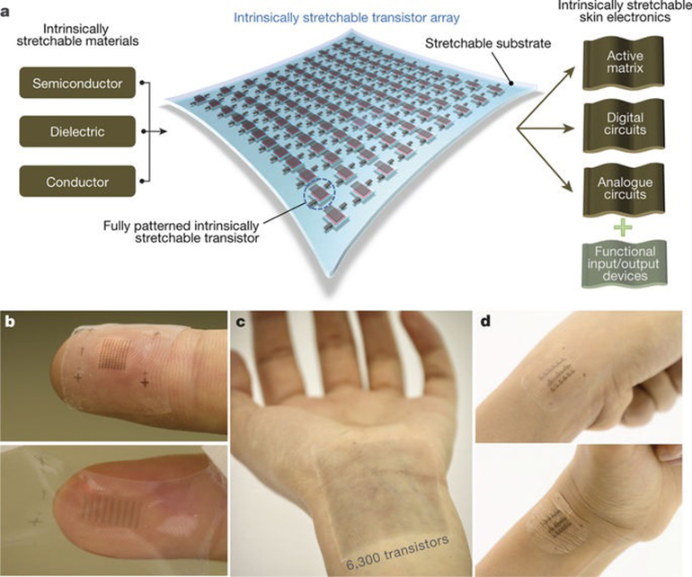Their paper “Skin electronics from scalable fabrication of an intrinsically stretchable transistor array” published in Nature, plus the detailed Supplementary Information packet, provides details on the concept, design, fabrication, and performance. (The project is supported by Samsung Electronics, the National Science Foundation Graduate Research Fellowship Program, and NETEP and MOTIE of the Republic of Korea.)

Figure 8: Shown are key aspects of the use of the intrinsically stretchable transistor array as a core platform for functional skin electronics. (Source: Stanford University)

The sensing skin is based on intrinsically stretchable polymer materials, a relatively new technology. The team developed a transistor matrix with an unprecedented device density for this class of materials of 347 transistors per square centimeter (note the order-of-magnitudes difference between this density figure and even an early-generation IC). The team produced square devices that are about two inches (5 cm) on a side and contain more than 6,000 individual signal-processing devices acting like synthetic nerve endings, all fully encapsulated in a waterproof protective layer (Fig. 1).

Key to the advance is a production process using multiple layers of specialized, highly advanced polymers—some provide elasticity and some act as electrical insulators, while others provide the intricately patterned electronic mesh. The multistep production process includes use of an inkjet printer, which paints some layers on the built-up configuration. The “skin” includes an active-transistor matrix for the sensory array, as well as analog and digital circuit elements.

The overall process is comparable in overall complexity (although very different otherwise) to a conventional IC from chemical, material, and production-sequence perspectives, and obviously has much-larger feature size. Bao says that her achievement is not only in the concept and prototype, but also an effective series of steps to mass-produce this class of flexible, stretchable electronics.

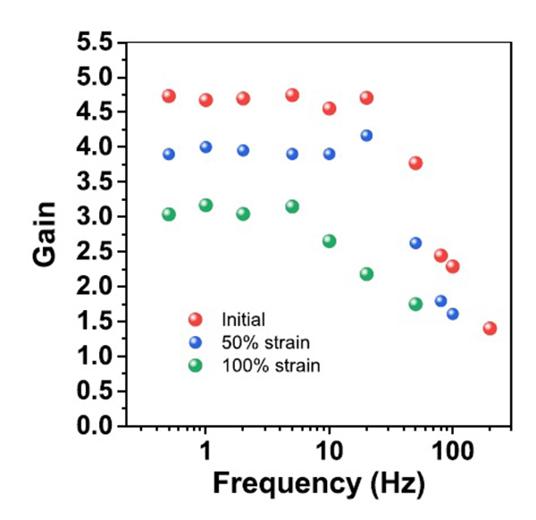The electronic skin is much more than just flexible—it’s also highly stretchable, which is alien to the experience and even thinking of most engineers. It can be stretched to twice its natural size (100% strain) and when returned to its initial size, it retains its ability to conduct electricity yet not show cracks, delamination, or wrinkles. A test sample was stretched over 100 times without significant damage and was even attached to a human hand as a “second skin” without impairment.

Figure 9: Frequency responses of the amplifier at strains of 0%, 50% and 100% from dc to about 100 Hz shows modest flatness. (Source: Stanford University)

The average charge-carrier mobility of the resulting transistors was comparable to that of amorphous silicon, varying only slightly (within an order of magnitude) under conditions of 100% strain/1000 cycles, and showed no current/voltage hysteresis. Amplifier gain was also fairly stable from dc to 100 Hz (yes—that’s 100 Hz, and adequate for the application) at strains of 0, 50, and 100% (Fig. 2).

As with most demonstration research prototypes, going from the lab to production is often as large a challenge as the initial R&D effort itself (think of all those promising battery chemistries which could not be commercialized due to production issues). Bao says her process is compatible with mass-production requirements.

She added that the long-range goal of her research is to enable manufacturing of sheets of polymer-based electronics embedded with a broad variety of sensors that could become flexible, multipurpose circuits and work with a person’s existing nervous system. The result would be similar to the complex sensory network and surface-protection aspects of human skin.

**Desirable Properties For E-Skin:**

E-skin can mimic the properties of human skin in its ability to sense tactile forces, as well as augment the capabilities of human skin through incorporation of chemical and biological sensing functionalities.

## Biocompatibility and Biodegradability

Since e-skin applications require intimate association with biological interfaces, biocompatibility is an important consideration for such devices. Ideally, e-skin should be synthesized from highly biocompatible components.

## Self -healing

While naturally occurring human skin has the ability to repair itself after incurring mechanical damage, this property has yet to be fully realized in e-skin. For artificial skin, the ability to repair both mechanical and electrical damage would be highly advantageous for practical applications. There are two predominant strategies used to incorporate self-healing properties into materials, namely: 1) the use of materials loaded with healing agents and 2) the use of materials containing dynamic reversible bonds. The incorporation of capsules containing healants was first demonstrated in self-healing, non-conducting polymers. However, for e-skin applications, it is necessary to use a system that is electrically active.

## Temperature sensitivity

Sensing temperature is a key functionality of human skin that helps to prevent injury and provides information about the surrounding environment, most tactile sensors are inherently temperature sensitive, and their response must therefore be calibrated with a temperature sensor. Several groups have implemented piezoelectric pyroelectric sensors that can discriminate between temperature and pressure inputs. Resistive temperature detectors (RTD) are attractive for e-skin applications owing to their flexibility, simple device structure, and compatibility with electronic readout methods.

RTDs relate a change in temperature to a corresponding resistance change through a material commonly composed of metals such as Au and platinum (Pt). To deconvolute the contribution of tactile stimuli from temperature sensors, meandering sections of Pt as temperature-sensing devices were implemented . These devices achieved a resolution of 0.03 °C over a wide range of temperatures. stretchable temperature sensors based on thin, buckled Au lines are also demonstrated .While the linear behavior of this sensor was attractive, the change in resistance was relatively small, and would require a sensitive readout mechanism.

## Self – Powering

Providing a long-lasting supply of power is a persistent challenge for mobile electronics. As the largest human organ, skin provides a large area for potential energy storage. Furthermore, as the body’s interface with the outside world, e-skins may provide the opportunity to scavenge energy from environmental sources such as light and mechanical forces. A number of promising technologies have recently been demonstrated for power generation, transmission, and storage in stretchable systems, including solar cells, mechanical energy harvesters, super-capacitors, batteries, and wireless antennas. Light is a readily available power source, and is most effectively harvested using devices with large surface area. stretchable solar cells based on rigid GaAs device islands connected with freestanding metal interconnects are determined . These solar cells operated with an efficiency of ≈13% with applied strain of up to 20%. Although these devices provided exceptional performance, the high cost of GaAs may limit its implementation in large-area e-skins. OPVs on ultrathin substrates using conventional materials and processes are fabricated . By transferring the devices to a prestretched substrate, they were able to achieve a stretchability up to 400% with an efficiency of 4%.

Technologies for harnessing mechanical energy include both dielectric elastomer generators and piezoelectric generators. Dielectric elastomer generators consist of an elastomeric dielectric coated with two highly compliant electrodes, and their stretchability makes them attractive for use in e-skin. The electrodes are charged by applying a voltage in the compressed state. Relaxation of the elastomer increases the voltage, producing higher energy charges that are harvested. Dielectric elastomer generators can achieve very high efficiencies, but have historically been limited by the complexity and weight of the associated electronics. Recent reports have demonstrated that the circuit complexity can be reduced using systems that are self-primed or primed by electrets. Mechanical energy harvesting devices based on nanostructured piezoelectric materials have also been developed, and stretchable versions have been fabricated by buckling the active materials. Fueled by the development of new soft materials, the field of mechanically compliant energy storage technologies has recently emerged.

Supercapacitors store energy in the form ofdouble layers of charged species residing at the electrode–electrolyte interface and provide very high power densities. Buckled CNT electrodes on prestrained substrates have been used to make supercapacitors that are stretchable up to 30%.

Advantages**:**

1. Reduces number of wires

2. Compact in size

3. Attachment and detachment is easy

4. More flexible

5. Light in weight

6. It replaces present system of ECG and EEG

7. It gives sense to a robot

8. Ultrathin

9. Twistable & stretchable

10. Easy to handle

Disadvantages**:**

1. Continuous emission of dead cells does not take place

2. Transpiration doesn’t take properly

3. Single Use

4. Cost is high

**Flowchart:**

FrequencyAvailable?

Is Connected?

Connecting

No

Yes

Input frequency

No

Yes

Measure Frequency

Temperature, power and other input parameters

Measuring input parameters

Yes

Data

Received?

Signals

Available?

No No

Yes Yes

Data Output

Start Sending data

to the Receiver

Figure 10: Working mechanism of electronic skin in flowchart

**Applications:**

Using the technologies described in previous sections, highly integrated systems of mechanically compliant sensor arrays possessing multiple functionalities have been reported. A select number of recent advancements will be described in this section, along with some of their demonstrated applications in the fields of biomedical devices, robotics, and optoelectronics.

## Biomedical Devices

Active electrode arrays have been demonstrated for measuring electrical activity in both the heart and brain. The mechanical compliance of these arrays was essential for achieving conformal interactions with these irregularly shaped organs. For measuring electrocardiogram signals, an array of 2016 transistors was used to achieve good temporal resolution at 288 contact points, thus allowing for high-resolution spatial mapping of electrical characteristics. A similar flexible array of active electrodes was used to measure brain activity with unprecedented spatial accuracy.

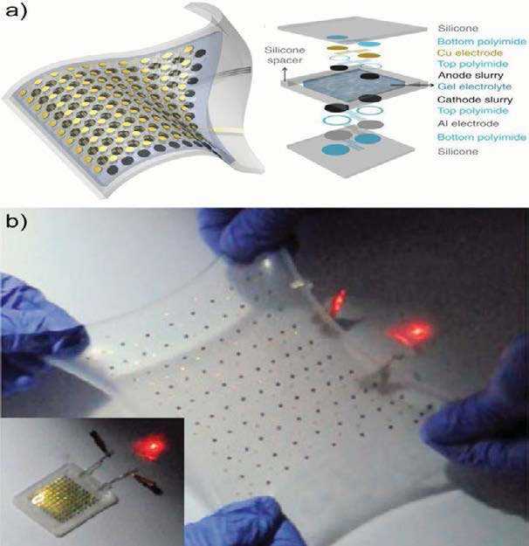

Figure 11: Demonstration of stretchable lithium ion batteries.

a) Illustration of a stretchable device with an exploded view of the various layers in the battery structure.

b) Operation of a battery that has been biaxially stretched to 300% powering a red LED. Inset shows the un stretched device

## Robotics

Compliant devices with integrated tactile functionality could be used as skin-like sensors for intelligent robots. One of the first flexible and highly multifunctional skin-like systems was reported using polymer micromachining technologies. An array of several sensor types allowed the measurement of numerous desired parameters such as contact forces, object hardness, temperature, thermal conductivity, and surface curvature. However, the system lacked multiplexing for large-scale implementation.

Over the last decade, a series of increasingly more complex stretchable circuits with multiple functionalities were reported. A flexible active matrix of pressure and temperature sensors was first reported in 2004,and stretchability was subsequently added by the selective removal of periodic sections of the flexible substrate. To increase the device’s stretchability, stretchable interconnects were implemented by developing a highly conductive and stretchable material comprised of a fluorinated elastomer and ionic liquid with long CNTs. The stretchable material was later formulated to be printable, thus improving the throughput and cost effectiveness of the device’s manufacturing process.

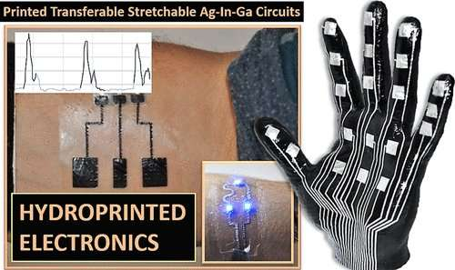The adopted active matrix technology has subsequently been used to drive a range of devices, including pressure sensors, temperature sensors, electromagnetic interference sensors, and actuators for tactile feedback arrays. By integrating a floating gate into their OFETs, pixels with memory capabilities were created that could locally store information from piezoresistive elements. For device readout, local memory is important to capture transient events that may be shorter than the readout time of the sensor array and to provide a ―snapshot‖ of an instantaneous distribution of the stimulus.

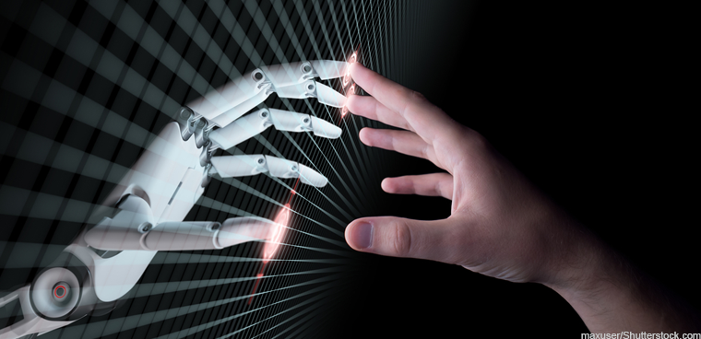

Figure 12: Flexible: Electronic skin aids Human-Machine Interaction

## Optoelectronics

Stretchable optoelectronics for applications such as stretchable or semitransparent displays, biomedical imaging, and hemispherical photo-detector (PD) arrays are promising. Traditional planar PD arrays require complicated optics and/or image correction software to extract an accurate image. Curved PDs similar to the human retina have been developed that can simplify the required optics, reducing the cost and weight of the detector. Furthermore, detectors with adjustable forms can provide dynamically tunable zoom and focusing and can mimic the sophisticated imaging system of insect eyes.

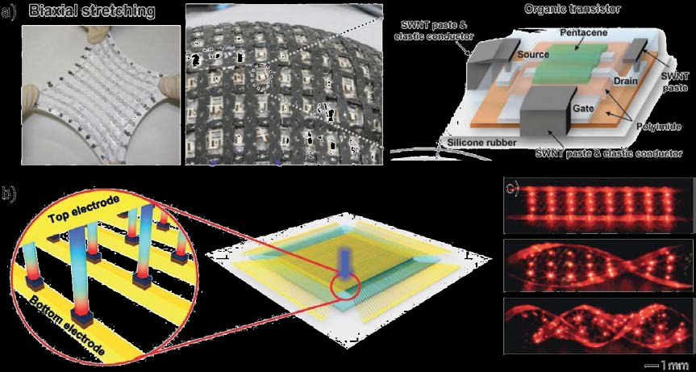

Figure 13: Highly integrated e-skins for robotics and optoelectronic applications

a) Stretchable active matrix devices including biaxial stretching of an integrated, encapsulated device demonstrating a conformal coverage of a non-planar surface (left), and a depiction of an individual organic transistor in the array (right).

b) Depiction of piezoelectric NWs used as an array of active tactile sensors with unprecedented spatial density

# **Flexible Electronic Skin to sense Magnetic Fields**:

Everyone learns in school that humans have five basic senses: touch, sight, hearing, taste, and smell. There are actually several more, but one that humans don’t inherently have is magnetoception, the ability to perceive magnetic fields. This sense can be found in certain bacteria, migratory birds, fish, and invertebrates, and provides a better sense of navigation and orientation. A new paper published in Nature Communication by lead author Michael Melzer of the Leibniz Institute for Solid State and Materials Research in Dresden, Germany describes a new electronic skin, which provides a “sense” of magnetic fields that will have a wealth of implications when it is developed further.

The electronic skin contains an array of magneto resistive sensor foils which sense both static and dynamic magnetic fields. The sensors are made from layers of cobalt and copper, with polyethylene terephthalate (PET) film. Information about the sensor’s proximity to a magnetic field is transmitted wirelessly to an external device that has LED indicators, giving a visual representation of the distance.

The skin is only about two micrometers thick, which is about one-fifth as wide as a single human hair. A square meter of the material only weighs three grams, which makes it light enough to rest on a soap bubble, as can be seen above. It is also incredibly elastic, as it is able to stretch over 270% in multiple directions over 1,000 times before wearing out. Conversely, the sensors are still able to function properly if the skin is crumpled up. These features make them well-suited for use on the skin.

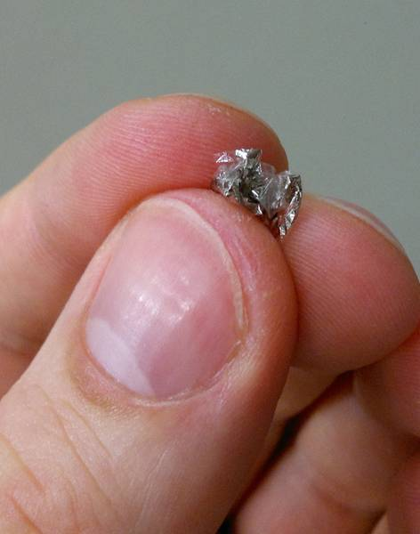

Figure 14: The electronic skin is resilient enough to be functional, even after it has been crumpled

"These ultrathin magnetic sensors with extraordinary mechanical robustness are ideally suited to be wearable, yet unobtrusive and imperceptible for orientation and manipulation aids," senior author Oliver Schmidt explained.

In the future, this technology could be used with biomedical implants such as artificial muscles or joints to detect anomalous behaviour, and could also be used to improve the fine motor skills of soft robotics.

**Future Scope:**

Skin plays an important role in mediating our interactions with the world. Specifically, human skin can sense pressure and temperature, stretch, and heal itself. Electronic skin is a thin electronic material that mimics human skin in one or more ways. Recreating the properties of skin using electronic devices could have profound implications in various fields like robotics, prosthetics and medicine. The artificial skin could one day be used on robotic hands capable of detecting diseases or intoxication of humans via touch.

The pursuit of artificial skin has inspired innovations in materials to imitate skin’s unique characteristics, including mechanical durability and stretch ability, biodegradability, and the ability to measure a diversity of complex sensations over large areas. New materials and fabrication strategies are being developed to make mechanically compliant and multifunctional skin-like electronics, and improve brain-machine interfaces that enable transmission of skin’s signals into the body.

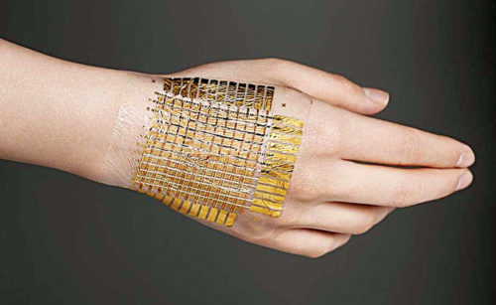Scientists and engineers have made progress toward materials that can detect pressure, blend with surroundings, measure body temperature, and do much more. Here is a summary.

Figure 15: Ulsan National Institute’s electronic skin that can detect changes in both temperature and pressure

## Self-healing electronic skin

Stanford University researchers have developed an electronic skin capable of healing itself by combining a self-healing plastic and nickel, a conductive metal. Unlike self-healing polymers developed by other researchers, this skin did not require a high temperature or UV light to activate.

The individual plastic molecules of the skin break apart relatively easily, but the bonds also easily reform. Cut pieces healed to 75 per cent strength within a few seconds and fully in less than 30 minutes when pressed together at room temperature. Additionally, the process could be repeated many times—in experiments the material showed near-perfect healing after 50 breaks. Other self-healing materials alter their structures in the process and thus can heal only once.

In addition to being self-healing, the electronic skin was pressure-sensitive and very flexible. It was the first material to exhibit all these properties at the same time. It was also the first conductive self-healing polymer. The e-skin could detect both downward pressure and pressure from bending; thus, in principle, it could detect both the pressure and angle of a normal human handshake.

According to the research team, the material could be useful in prosthetics and creating self-healing wires for electronic devices.

## Lighting electronic skin

Researchers from the University of California at Berkeley have created an electronic skin that lights up when touched. Pressure triggered a reaction in the skin that lit up blue, green, red and yellow LEDs; as pressure increased the lights got brighter.

The material was composed of synthetic rubber and plastic, and was thinner than a piece of paper. Sandwiched between layers, organic LEDs were lit by semiconductor-enriched carbon nanotubes and a conductive silver ink. The skin was made up of hundreds of circuits, each of which contained a pressure sensor, a transistor and a tiny LED. Pressure changed the resistance of the sensor, thereby changing the amount of electricity flowing into the LED.

The team suggested that the invention could be useful in skin for prosthetic limbs and robotics. One of the major problems with these kinds of light films in the past, though, was that these only lasted a matter of hours when exposed to normal air.

Making any piece of ultra-stretchy electronics often involves sandwiching materials together to produce something with the right properties, whether it’s for a red light or a method of sensing pressure. In this case, the researchers added a new protective coating, called a passivation layer, to various kinds of e-skin. The coating kept out oxygen and water vapour well enough to keep the light working for several days. Researchers report that this power LED film also produced less heat and consumed less power than previous efforts. The coating they used can also work on e-skin that does more than just light up.

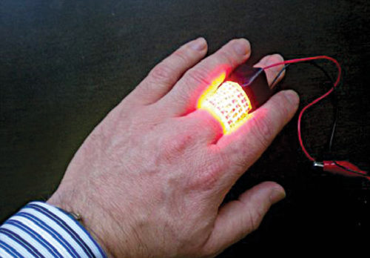

Figure 16: Electronic skin that lights up when touched

## Sweating electronic skin

A Northwestern University research team has developed a first-of-its-kind soft, flexible microfluidic device that easily adheres to the skin and measures the wearer’s sweat to show how his body is responding to exercise.

A little larger than a quarter and about the same thickness, the simple, low-cost device analyses key biomarkers to help the user decide quickly if any adjustments, such as drinking more water or replenishing electrolytes, need to be made or if something is medically awry.

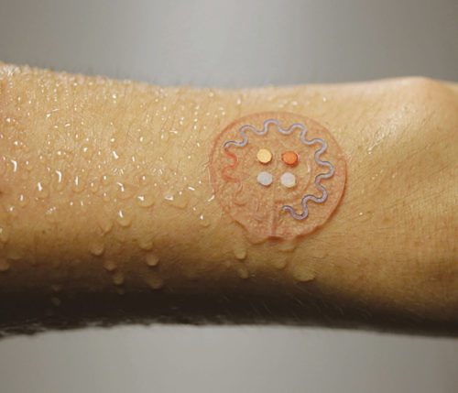

Figure 17: Sweating Electronic Skin

Designed for one-time use of a few hours, the device, placed directly on the skin of the forearm or back, even detects the presence of a biomarker for cystic fibrosis. In the future, it may be more broadly used for disease diagnosis.’

## Other Scopes

1. Bendable sensors and displays have made the tech rounds before.

2. We can predict a patient of an oncoming heart attack hours in advance.

3. In future even virtual screens may be placed on device for knowing our body functions.

4. Used in car dashboard, interactive wallpapers, smart watches.

**Conclusions:**

In the past decade, the pace of e-skin development has accelerated dramatically owing to the availability of new materials and processes. As a result of this progress, the capabilities of e-skin are rapidly converging.

Interest in e-skin has been driven by its potential to:

1. To enable highly the development of interactive and versatile robots that are capable of performing complex tasks in less structured environments.

2. To facilitate conformable displays and optics.

3. To revolutionize healthcare by providing biometric prostheses, constant health monitoring technologies, and unprecedented diagnostic and treatment proficiency.

Sensors and circuits have already exceeded the properties of biological skin in many respects. Electronic devices have been fabricated that stretch many times further than skin, flexible tactile sensors have been demonstrated that possess vastly superior spatial resolution to human skin, and tactile and temperature sensors are available with enhanced sensitivity over their natural counterpart.

Despite rapid progress, there is a continuing need for further development before the goal of integrating multiple functionalities into large-area, low-cost sensor arrays is realized. From a design standpoint, e-skin requires active circuitry to address large numbers of devices with minimal wiring complexity and fast scan rates. Furthermore, the ability to mimic the mechanical properties of human skin (e.g., flexibility and stretchability) is critical in order to accommodate the various movements of the user. This can be accomplished through the use of intrinsically stretchable materials or rigid device islands tethered together through flexible interconnects. While the latter leverages the extensive optimization of rigid devices, the former may have advantages in terms of cost and robustness.

One of the most important functions of skin is to facilitate the sense of touch, which includes normal force sensing for grip optimization, tensile strain sensing for proprioception, shear force sensing for object manipulation, and vibration sensing for slip detection and texture analysis. While the commonly used transduction methods (such as piezoresistive, capacitive, piezoelectric, optical, and wireless) are readily available, advancements in device structures and materials have produced dramatic improvements in tactile sensor performance. For example, improvements in processes to create microstructured and nanostructured materials have presented exciting opportunities for smaller devices suitable for high-density arrays with low power consumption and excellent performance. However, further optimization of materials and device configurations is still necessary. For example, the piezoresistive composites that are currently used in some integrated systems display viscoelasticity that may potentially be overcome using matrix-free structures of nanomaterials.

Different transduction methods provide different sensing capabilities, thus allowing integrated systems to mimic the multifunctional nature of human tactile sensing capabilities. For example, large strains can be reliably measured using piezoresistive devices, capacitive devices can provide high sensitivity to normal forces, and piezoelectrics can measure vibrations. Integration and readout is one of the most important development areas for large area sensor arrays. Active matrices have been developed that provide a method of multiplexing large arrays with fast addressing and minimal crosstalk between pixels. Future work will probably involve continuing efforts to improve the performance and reduce the cost of tactile devices integrated with transistor matrices. Furthermore, integrating multiple functionalities (such as temperature, shear, and vibration sensing) with active matrix arrays is an area of tremendous opportunity.

Several highly integrated e-skins demonstrating multiple functionalities for applications such as biomedical devices, robotics, and optoelectronics have been recently reported. One particular challenge in the future of e-skin will be neural interfacing. Work has already begun to overcome this obstacle, and recently, a neurally controlled robotic arm capable of 3D reach and grasp movements was reported. Additionally, a bionic ear has been demonstrated with the capability to receive RF signals beyond that of the human ear. The rapid pace of progress in e-skin technology suggests that the fabrication of a more complex e-skin with properties far surpassing those of their organic equivalent will soon be possible.

**References:**

[1] <http://en.wikipedia.org/wiki/Electronic_skin>

[2] <http://www.ncbi.nlm.nih.gov/pubmed/24151185>

[3] <https://student.societyforscience.org/article/electronic-skin>

[4] <http://www.nature.com/news/electronic-skin-equipped-with-memory-1.14952>

[5] <http://www.sciencedirect.com/science/article/pii/S1386947704002644>

[6] <http://www.nature.com/nmat/journal/v12/n10/full/nmat3711.html>

[7] <http://www.nature.com/ncomms/journal/v4/n5/full/ncomms2832.html>

**THANK YOU**